Troubleshooting the
Windows 10 Camera
Use the search tool on the bottom left of the task bar to search for “camera” , open the app. Click on settings (the cog wheel) then, make these changes: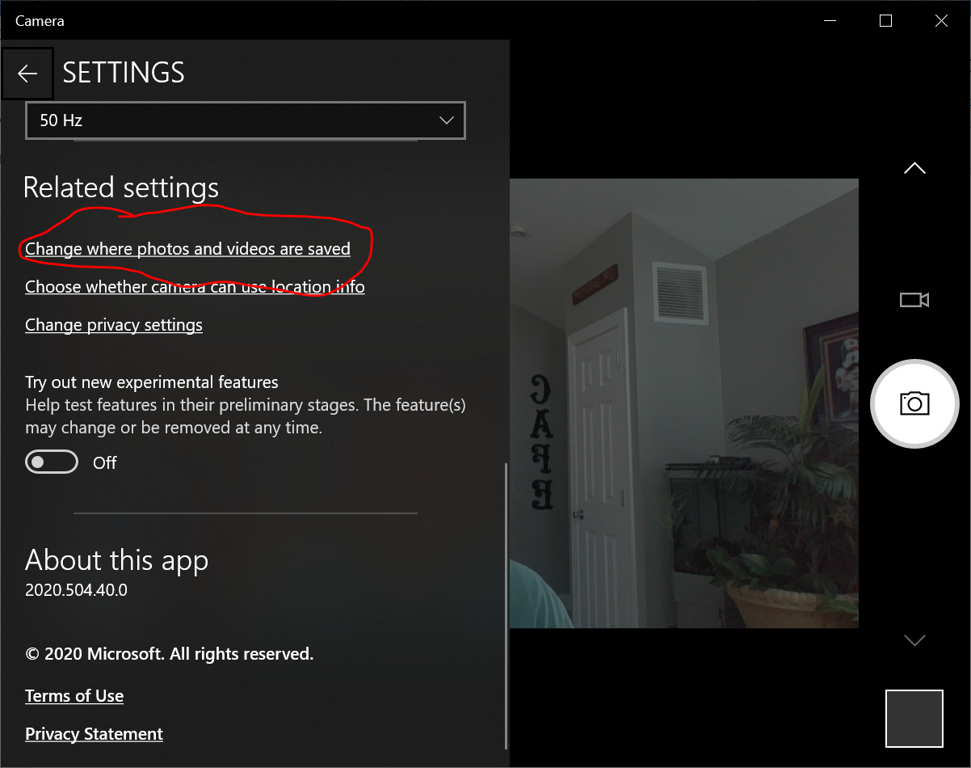
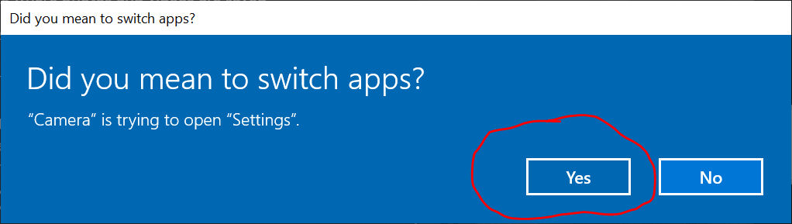
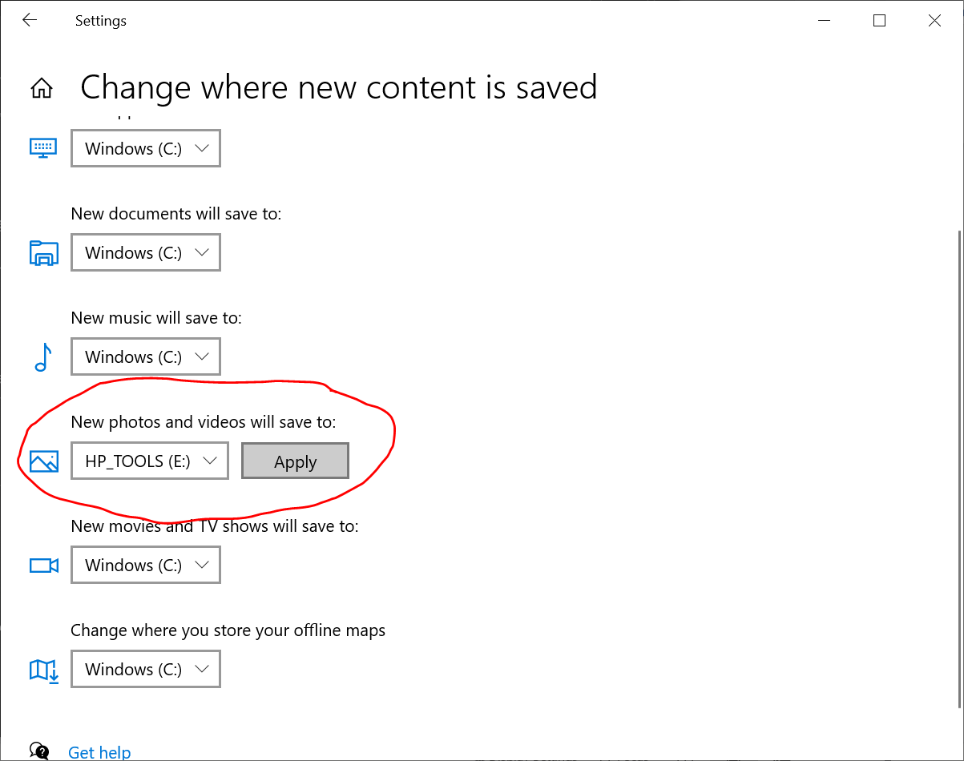
Choose “not (C)” -C is the hard drive. You are not allowed to save to the hard drive as a student
Mine is E, I am not sure what yours is as a student.
Now your camera and video will work at home.

