Troubleshooting the
Windows 10 Microphone
When using the built-in or an external microphone in Windows 10 sometimes the signal may be muted. This will give an error that the application cannot “hear” or see activity from the microphone. Or there will simply be nothing recorded in an application.
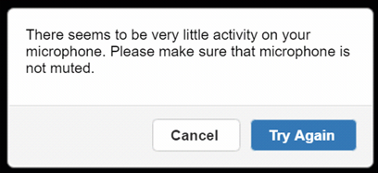

- Right-click the Speaker Icon in the bottom right-hand side of the system tray.
- Select Recording Devices from the menu options.
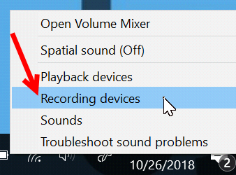
- Double-click the microphone or recording device in use. The example below shows the internal microphone.
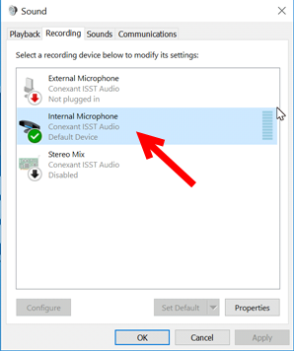
- Click the Levels Tab (1) and then make sure that there is not a mute indication on the small speaker icon (2).
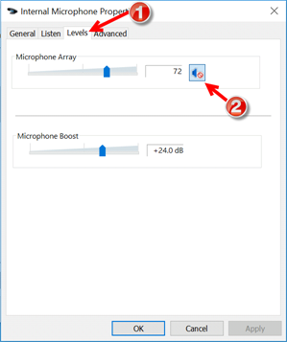
- Click the icon to remove the muting.
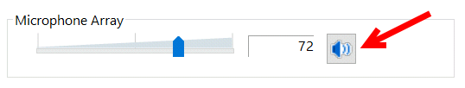
- Click the OK button to save the changes.
